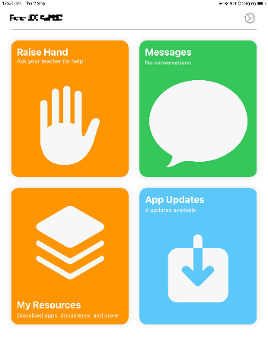 | The setup is completed and the app will open.  Click the cog icon to access the settings page
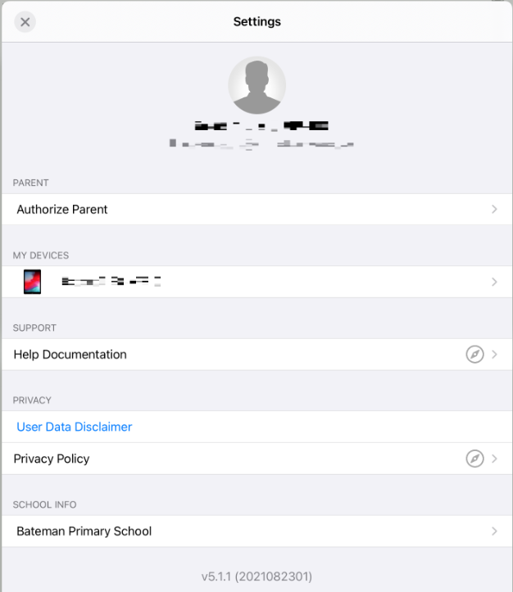 | Click on the student name to access the “device Info” page.
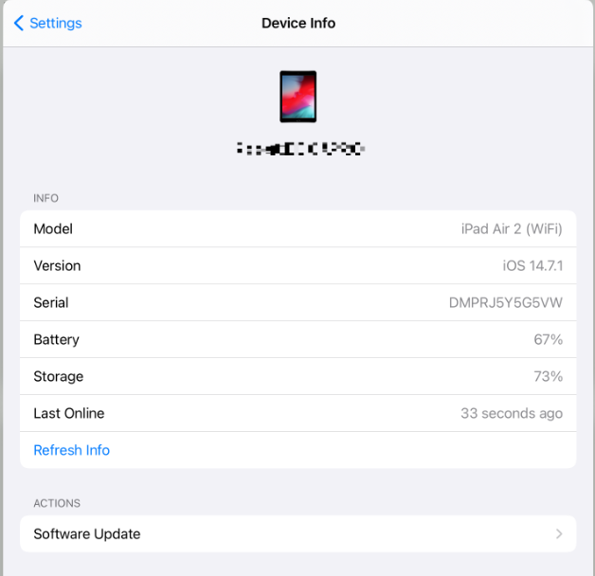 | Click the “Refresh Info”, this will check in with the main Jamf servers and update your current location.
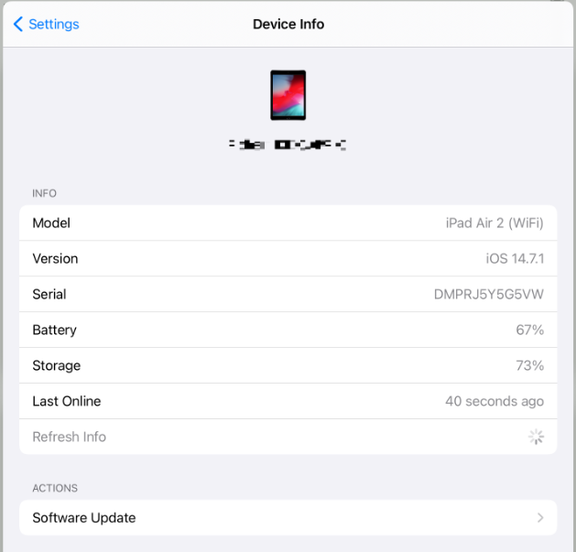 | When the busy indicator has stopped spinning, the device has completed its check in and its location updated.

