1:1 iPad Program Information Booklet

2023

PP - 6
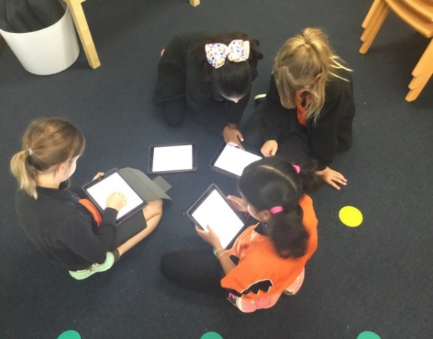

Introduction of the 1:1 iPad Program

The rate of development in technology is such that our lives are changing more rapidly than at any previous time in history. As educators, it is our responsibility to ensure that we prepare our students to participate in a society that will look vastly different to today. Our challenge is to prepare the children of today for a world that has yet to be created, for jobs yet to be invented and for technologies yet unknown.

The current generations of children are growing up with knowledge of, access to and an expectation that technology will be central to all they do. Having access to such technology (and therefore, immediate access to information) is no longer a luxury or extravagance, but an expected part of the lives of today’s children.

Bateman Primary School is addressing the challenges outlined above by having a 1:1 iPad program our Pre-primary to Year 6 students which commenced in 2019. For the program to work effectively, it is important that the iPad selected complies with the minimum specification outlined in this document to ensure the iPad is suitable for the learning task, is convenient and portable and most importantly, is adequately backed up by a rapid repair service in the event of a problem.

What is this 1:1 iPad Program?

The 1:1 iPad program is to engage students and enable them to develop the skills and habits to become successful 21st century learners within a school educational setting. The integration of technology will transform teaching pedagogy enabling teachers to implement highly refined individual programs for their students using iPads. This will ensure our students are developing the skills to think critically, problem solve, be creative and demonstrate innovation using iPad technology at home, school and in their community.

Teachers will still continue to teach lessons using established teaching and learning practices using iPad technology as a tool to enhance and personalise the curriculum for students. The amount of time spent using iPads in the classroom will vary depending on planned lessons.
As part of implementing the Western Australian Curriculum - ICT General Capabilities schools are expected to:
- Teach social and ethical protocols and practices
- Ensure students conduct investigations
- Provide opportunities to create
- Communicate ideas & information
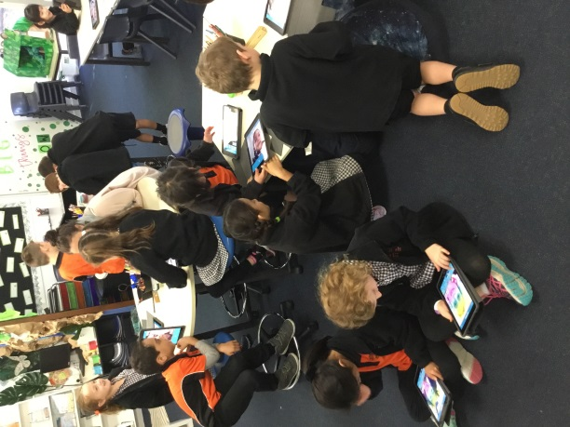
- Manage and operate

Our teachers will continue to integrate ICT and digital technologies into their current teaching program to support student learning as outlined in Bateman Primary School Business Plan 2020 – 2022 Focus Area 4: Student Achievement and Progress.

The iPad initiative will provide a key technology tool which will enable students to achieve these capabilities and prepare them for future education.
The iPad will be very effective in providing a number of tools within the one device which would normally require a number of hardware devices and software components.
While there are many education applications for literacy and numeracy, the iPads will also provide creative opportunities in the visual arts, music, languages and physical education well beyond the scope of what is possible today with our current school infrastructure. In addition, the iPad technology has proven an invaluable tool in supporting students with special learning needs. The school has already commenced a holistic and research based approach to ensure the success of the initiative. This includes support from teachers, students, parents, and infrastructure coupled with mentoring, professional development and regular review.

The iPad will enhance existing teaching and learning initiatives in the Western Australian Curriculum and will enable education delivery that would otherwise be impossible or impractical. The mobile nature of the device makes it easy to provide opportunities for teachers to effectively enhance teaching and learning initiatives both inside and outside of the classroom.

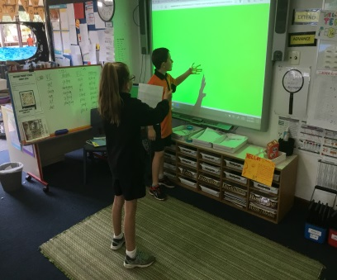
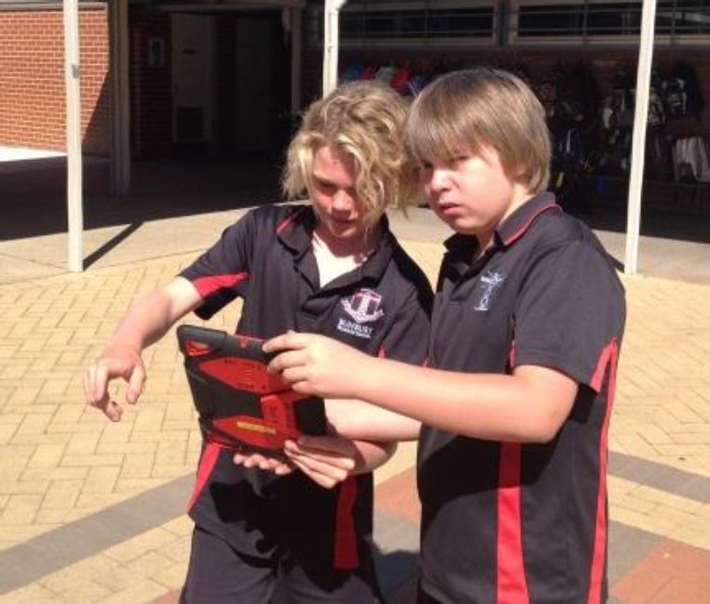
Teachers will continue to be supported, mentored and coached to adapt to using iPads as a tool in their classroom. It will encourage self-assessment, responsibility for individual learning and greater collaboration, both in the classroom and with the local and global community. At the beginning of each year, students will complete an online cyber safety program as part of the Western Australian Health Curriculum. (www.cybersmart.gov.au/kids.aspx)

Students and staff are required to also be aware of and practice responsible copyright procedures for both print and electronic materials. http://www.smartcopying.edu.au/

The iPad is a companion device. Its advantage is its mobility and ease of use. It will be used in scheduled, planned sessions to assist with the achievement of identified knowledge and skills.

Why only PP – Year 6?
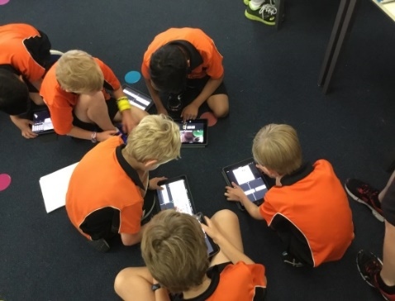
Our Kindy students will have access to our school owned iPads and will be immersed in the ICT General Capabilities and the Western Australian Digital Technologies throughout the school year, with a particular focus in Semester Two for our Kindy students to build their capacity before entering the program in Pre Primary.

The 1:1 iPad Program is NOT:

- Technology for the sake of technology
- Students using iPads all day
- At the expense of daily face-to-face teaching
- Replacing pen and paper, or teaching of correct handwriting skills
- Impacting on outdoor student activities
- Apps replacing teachers
- The only tool used for completing work or assessment.

What about equity?

Equity of access is core to the culture of the school.

The school is already successfully using iPad technology with all our students inside and outside of the classroom. Teachers will have access to the school’s bank of iPads, as they do now. These will continue to be divided between the classes to support those who may not have one that day.

Students without an iPad may need to share a school device and won’t have it available for use at home. This includes students whose iPad is in for repair or forgot to bring it to school.

The iPad is a tool that complements current teaching and learning practices. It does not replace them. A key difference will be that those students who do have their own iPad will typically complete most tasks quicker because they have more access, including home use.

Why has the school chosen the BYOD approach?

The advantages of a student using their own personal device are numerous. These include:

- There is no need to wait for an iPad to become available to commence and complete work.
- Not having to wait for another class to finish using them
- Provides ability to work on internet related research
- Ability to store media and documents without interference by other students, either accidental or intentional
- The student’s documents cannot be edited or deleted by other students who might use the device.
- Each device can be individual monitored. (Multiple device users would have to be recorded to be monitored. Even then proving who was using the device at the time of an issue would be difficult).
- Wireless access provides the ability to email documents and search the Internet when needed.
- The school is moving towards more sustainable practices and reducing our impact on the environment.

If my child already has a tablet that is not an iPad, can they use that at school? i.e. Android or Windows

Unfortunately, this is an iPad only program which means other devices such as Android or Windows cannot be supported.
- The decision to use iPads is based on the following reasons:
- The school requires iPads primarily to ensure the same applications are available across all devices.
- This also extends to methods for submission of work and in classroom presentation on the projector.
- Importantly our staff are and will continue to be trained to support learning and troubleshooting on iPads.
- Apple has an Education Team that provides guidance, support and professional development second to none.
- Apple has a track record of supporting the iPad with operating system and security updates far beyond the supported lifetime of other tablets. Importantly these updates are available worldwide without delay. These two factors are considerable in terms of online safety and the longevity of investment in the device.
- Apple has a rigorous vetting process of all Apps (this includes educational Apps) submitted to the app store.
- Teachers have access to over 500 000 Apps of which 20 000 are designed specifically for educational purposes.
- Teachers can facilitate a change in student workflow through the multi-media capabilities of the device. This can include the design of digital eBooks and iMovies. These applications are only available on an iPad device.
- Of all tablet devices, the iPad is the current market leader. It has a responsive Multi-touch screen and a large, high-resolution LED-backlit IPS display. The iPad is compact, lightweight and portable. A battery life of 10 hours will be adequate for the whole school day.

If my child or the families already have an iPad, can they use it at school?

Yes, as long as the iPad meets the minimum hardware requirements listed below and adhere to the school’s policy regarding appropriateness of Apps and media, including background pictures. Please note: if you choose to send along a personally owned iPad, please ensure that all contents have been backed up as the iPad will be reset to factory settings for the school to be able to install the mobile deployment management system.

Which iPad models can be used?

The minimum specification requirements:

iPad 7th generation 32 GB (released September 2019)
iPad 8th generation 32 GB (released September 2020)
iPad 9th generation 64 GB (released September 2021)
iPad 10th generation 64 GB (released November 2022)
No SIM card or 3G/4G/5G capability
It must be able to function with iOS 16
Whilst the iPad Mini may meet the recommended storage and operating system, the smaller screen size is not optimal for all apps in the classroom and does not meet the requirements of NAPLAN Online. Therefore, for all students – iPad Minis will not be able to be used.

The recommended size for an iPad in an educational environment is 256 GB. Items that can be stored on the iPad include Apps, photos, videos and other media. 256 GB will enable students to store their work on the device without having to manage the content externally.
64GB should be sufficient however, please understand that this will require regular storage management.

It is anticipated that a new iPad will have a useful life of around 3+ years.

We are encouraging our families to purchase their iPad through Winthrop Australia. They provide a competitive price and bundle which includes AppleCare+ and cover.

Cost of Apps?

While many great applications are free some are not. Many free Apps come with advertisements that pop up during use and are not always appropriate (e.g. gambling). Free Apps also have limitations of what can be created, compared with the paid App. As a school we can purchase Apps at half price through the App Store and push the Apps out via Jamf School.

Teachers will carefully select applications first and foremost for their intended use, while also keeping in mind the cost. The school aims to purchase cross curricular Apps such as Book Creator, Popplet, Pic Collage (edu), Clips, Chatterpix, Graphic Organiser, Green Screen by Do Ink, iMovie, Kahoot etc…

There is no charge for the cost of the apps that are put onto the BYOD devices. The school covers the cost of the apps and the Mobile Device Management (Jamf School).

Apps and Consent

Each year, all parents are required to give their consent for students to be able to use the apps and websites at school. This is regardless of whether they have a BYOD device or using a school devise. A separate information sheet and permission note will be given to all parents at the beginning of the year and as students enroll throughout the year. The school reviews the apps list each year so a new form may need to be sent out to include any updates. If parents do not fill in the permission note, the school will understand that the parent has not given permission for their child to use those apps outlined in the information note.

Will I have to purchase additional Apple devices to support the iPad at home?

No. Devices are stand-alone which means they can be managed without an Apple computer. Should you choose to manage the iPad via a computer both Windows and Apple computers are compatible with iTunes which is software freely available from Apple.

Does the school have a policy on appropriate use of the iPad at school?

Yes, the school has developed a very thorough policy and user agreement for using the iPad at school. The policy extends to staff, student and parents. This includes students and parents being required to sign a 1:1 iPad Program - Acceptable Use Agreement for using iPads at school. The agreement clearly outlines student expectations and parent responsibilities and complements the existing school ICT online code of conduct document which was signed at enrolment. These documents will be made available to parents via the school website or upon request.

How will the school be managing the appropriate use of the device?
At school we will be using Jamf School (Zulu Desk). Jamf School allows us to:

- Control the use of non-educational Apps that are being used at school, such as Facebook, YouTube, Snapchat or Netflix.
- Block/control the students from installing Apps
- Block specific websites
To find out more information visit the site below:
https://www.jamf.com/solutions/technologies/apple-school-manager/
https://www.jamf.com/products/jamf-school/
Our teachers will also be using Apple Classroom which allows them to see what each student is doing on their iPad and locks the Apps that they are using on specific tasks.
What if my child breaks or loses the iPad?

At school staff will ensure:

- Students do not remove their iPad from the classroom during lunch or recess.
- Students are not on their devices before or after school.
- Their storage boxes are locked whenever the classroom is vacated.

When transporting the devices to and from school and during the school day, students must:

- Ensure that the device is in a protective cover
- Never leave their device unattended.
- When attending Mulberry Tree before and after school, the iPad is to be secured inside the assigned area.

Damage, Vandalism and/or loss of device on school grounds:

- The students and parents must accept full responsibility for the care and use of their own iPad.
- Bateman PS does not accept responsibility for theft or loss of the device (in parts or whole) or any accessories.
- It is recommended that families check the details of their personal insurance coverage for events of loss or damage to the device and if not already covered elect to purchase or include a suitable insurance option for the iPad, recognising that there is risk associated with a 1:1 iPad Program.
- In the event that damage should occur to the device, students will report this to the classroom teacher who will then complete an iPad Incident Report to be sent home with the student.
- No member of staff will attempt to fix any technical issues; this will be reported to parents/caregivers through an iPad Incident Report.
Amount of security/access with inappropriate sites
At school we will be using Jamf. Jamf allows us to:
- Control the use of non-educational Apps that are being used at school, such as Facebook, YouTube, Snapchat or Netflix.
- Block/control the students from installing Apps
- Block specific websites

Our teachers will also be using “Apple Classroom” which allows them to see what each student is doing on their iPad and locks the Apps that they are using on specific tasks.
We suggest the “Family Zone” App so that parents can have access to the device and monitor their child’s usage.
To find out more information visit the site below:
https://www.familyzone.com/au/
Cost of iPads for my child/ren

The advantages of a student using their own personal device are numerous. These include:

- There is no need to wait for an iPad to become available to commence and complete work.
- Not having to wait for another class to finish using them
- Provides ability to work on internet related research
- Ability to store media and documents without interference by other students, either accidental or intentional
- The student’s documents cannot be edited or deleted by other students who might use a school device therefore security of their personal data and work is ensured.
- Each device can be individual monitored. (Multiple device users would have to be recorded to be monitored. Even then proving who was using the device at the time of an issue would be difficult).
- Wireless access provides the ability to email or air drop documents and search the Internet when needed.
- Students can air play and share their documents with the class and teacher via the interactive projectors
It is anticipated that with the correct care, an iPad has a useful life of 3+ years and often will last your child throughout their primary school years. Harvey Norman, JB HiFi, Apple Store, Winthrop will provide interest free options (6, 12 or 18 months) when purchasing an iPad. Big W and Officeworks have the “AfterPay” option as well (4 weekly payments).
We recommend a heavy-duty case to protect your child/ren’s iPad – see example cases below.

Cases | Supplier | Photo
UAG Metropolis Case | Harvey Norman
Tech21 Evo Play2 Case for iPad (6th & 5th Generation) | Apple Store | 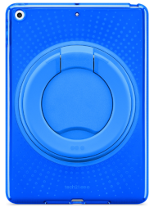
J.Burrows Rugged iPad Case | Officeworks | 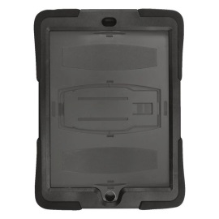
Griffin Survivor All-Terrain Rugged Case for iPad | JB HiFi | 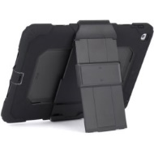
Smart Folio | Winthrop Australia/Apple Stores

What if my child forgets to take the iPad to school?

The school is already successfully using iPad technology with all our students inside and outside of the classroom. Teachers will have access to the school’s bank of iPads, as they do now.

Students without an iPad may need to share a school device and won’t have it available for use at home. This includes students whose iPad is in for repair or forgot to bring it to school.

The iPad is a tool that complements current teaching and learning practices. It does not replace them. A key difference will be that those students who do have their own iPad will typically complete most tasks quicker because they have more access, including home use.

Students will not be lending or sharing their personally owned iPad with other students.

What if my child forgets to charge the iPad?

The school has charging facilities for a number of iPads in each block, however, it is part of the user agreement that parents and students sign that there is an expectation that the iPad is charged ready for school. An iPad battery life is estimated at 10 hours.

What if I can’t afford to send an iPad?

A lease option is available for families who chose not to purchase an iPad outright.

The school is already successfully using iPad technology with all our students inside and outside of the classroom. Teachers will have access to the school’s bank of iPads, as they do now.

Students without an iPad may need to share a school device and won’t have it available for use at home. This includes students whose iPad is in for repair or forgot to bring it to school.

The iPad is a tool that complements current teaching and learning practices. It does not replace them. A key difference will be that those students who do have their own iPad will typically complete most tasks quicker because they have more access, including home use.

Will my children miss out?

Equity of access is core to the culture of the school.

The school is already successfully using iPad technology with all our students inside and outside of the classroom. Teachers will have access to the school’s bank of iPads, as they do now.

Students without an iPad may need to share a school device and won’t have it available for use at home. This includes students whose iPad is in for repair or forgot to bring it to school.

The iPad is a tool that complements current teaching and learning practices. It does not replace them. A key difference will be that those students who do have their own iPad will typically complete most tasks quicker because they have more access, including home use.

Bateman Primary would like to acknowledge the assistance of Success Primary in the production of this document.
Healthy tips for electronic device use at home and school

Children today are exposed to electronic devices on a daily basis. It is everywhere, and it is here to stay. Your child may already have access to a mobile device or tablet at home; with the new BYOD to school policy at Bateman PS in 2020, they are set to bring their own device to and from school each day for academic learning. It is important to set up healthy habits and routines for electronic usage as early as possible. Below are some tips and tricks that you may find helpful.

Set time limits and boundaries

The American Academy of Paediatrics (AAP, 2011) states that children under the age of 2 years should avoid television or media viewing altogether, with children 2-5 years of age limited to no more than 1 hour a day and 5-12-year olds limited to 2 hours of screen time each day (including television, iPads/tablets and gaming consoles). Many children have may reached these limits by the time they finish school.

Balance sedentary electronic use with physical activity

Encourage your child to take regular movement breaks. It is recommended that school-aged children get between 30-60 minutes of physical activity each day. If negotiating physical activity breaks with your child is turning into a battle, there are some great resources available that support parents and children to balance active and passive activity time. The “Green Time vs Screen Time” Tool from Nature Play WA is a great one- www.natureplaywa.org.au/resources/green-time-vs-screen-time

Consider your child’s posture- setting up a suitable environment

It is important children adopt healthy postures when using electronic devices. Increasingly, children are adopting a c-curve posture, often due to sitting in chairs with devices in their laps without adequate support. Children should:
- sit on an appropriate height chair with lumbar support
- sit with feet flat on the floor
- top of the screen should be at eye level
- tablet covers with stands and supports are highly recommended so hands/arms are free to move
- use a sturdy bag to transport their device- consider the extra weight in backpacks, especially for young children.
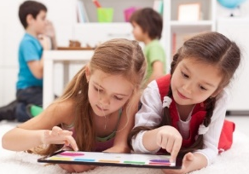
Encourage your child to change position while they are using their devices - lying on their tummies or backs can give tired muscles a break. Lying on their tummy also encourages your child to activate their core muscles (neck, back and tummy muscles) which sitting on a couch or bed does not!

Avoid eye strain and brain drain!

Daily use of devices, for extended periods of time, can lead to problems with vision. Digital eye strain (DES) encompasses a range of symptoms, including vision stress, dry eye or watery eyes, excessive blinking, muscle fatigue or twitching and blurred vision. Teach your child to recognise the signs of eye strain. Break up your child’s use of devices at home with periods of rest time so their eyes get a break. Natural light/daylight is much healthier for our eyes.
Electronic devices are usually LED-illuminated and emit high levels of blue light, which has been shown to suppress melatonin (which helps regulate our body’s natural rhythms) and disrupts our natural sleep cycle (Guttmann & Guttmann, 2017).
In children, too much blue light exposure from devices can lead to sleep disturbances and tired children in the morning- even if they have still had a good amount of sleep. When you consider that children have likely been exposed to increased levels of blue light throughout the day (interactive whiteboards, iPads/laptops and televisions) reducing the use of screens in the evenings is recommended. Bedrooms should be a device-free zone!
Monitor usage and appropriateness of apps
It is recommended caregivers use parental control options on devices and when using the internet. Educational apps used for school are usually more appropriate than fast-paced games and apps, with less rapid-fire changes that affect the visual processing system and the brain.
Caregivers also need to model appropriate screen usage- participate with your child on set homework tasks and consider reducing the amount of screen-time you use at home, particularly around daily routines (mealtimes, reading/homework, just before child’s bedtime).
Bree Harmsen, Occupational Therapist (Skills 2 Learn Occupational Therapy Services).

American Academy of Pediatrics. (2011). Media us by children younger than 2 years. Pediatrics, 128(5), 1-6. doi: 10/12/peds.2011-1753
Guttman, A. & Guttmann, E. (2017, March 28). What screen time and screen media do to your child’s brain and sensory processing ability. Retrieved from: http://handsonotrehab.com/screen-time-brain-sensory-processing/

